PYTHON PyQt5 + DATABASE CONNECTION ASSIGNMENT
Student Information Management System

Name | Lennox Lewis Odhiambo
Registration No. | IN17/00141/23

Tools Used
- Azure Data Studio (SSMS Alternative for Linux)
- PyQt5 Tools
- Jupyter Lab
- Designer ToolKit
- Pyuic5

System Overview
The Student Information Management System is a desktop application built using PyQt5 for the graphical interface and SQL Server for the database backend. It allows the user to perform CRUD operations (Create, Read, Update, Delete) on student records, search for specific students, and navigate through records. The system also supports resetting the database and ensures proper validation of input fields.

Procedure Overview
- Creation of the student database via Azure Data Studio
- UI building via the Designer QT interface — using elements such as text boxes, radio buttons, line text, and labels
- Conversion to .py file using the Pyuic5 Python package
- Database connection using ODBC and password authentication
- Main Python file scripting and testing — adding functionalities to UI elements
- Final usability testing and error debugging

Step 1: Database Creation
This step involved creating the database that would be connected to the frontend. The schema was implemented using SQL and created through Azure Data Studio using the following SQL script:

-- Create Database
CREATE DATABASE University;

-- Use the Database
USE University;

-- Create Students Table
CREATE TABLE Students (
RegistrationNumber VARCHAR(20) PRIMARY KEY,
FirstName VARCHAR(50) NOT NULL,
SecondName VARCHAR(50),
Surname VARCHAR(50) NOT NULL,
Course VARCHAR(100) NOT NULL,
County VARCHAR(50),
Gender VARCHAR(10),
Department VARCHAR(100),
School VARCHAR(100)
);

-- Insert Sample Data
INSERT INTO Students VALUES
('IN17/00001/23', 'Brian', 'Otieno', 'Omondi', 'Computer Science', 'Kisumu', 'Male', 'ICT', 'School of Computing'),
('IN17/00002/23', 'Faith', 'Wanjiku', 'Mwangi', 'Information Technology', 'Kiambu', 'Female', 'ICT', 'School of Computing'),
('IN17/00003/23', 'Kevin', 'Kiptoo', 'Cheruiyot', 'Software Engineering', 'Uasin Gishu', 'Male', 'ICT', 'School of Computing'),
('IN17/00004/23', 'Mercy', 'Achieng', 'Odhiambo', 'Business Administration','Homa Bay', 'Female', 'Business', 'School of Business'),
('IN17/00005/23', 'Dennis', 'Mutua', 'Musyoka', 'Accounting', 'Machakos', 'Male', 'Finance', 'School of Business'),
('IN17/00006/23', 'Esther', 'Naliaka', 'Wekesa', 'Nursing', 'Bungoma', 'Female', 'Health Sciences','School of Health'),
('IN17/00007/23', 'James', 'Kamau', 'Njoroge', 'Civil Engineering', 'Nyeri', 'Male', 'Engineering', 'School of Engineering'),
('IN17/00008/23', 'Lilian', 'Chebet', 'Koech', 'Education Arts', 'Kericho', 'Female', 'Education', 'School of Education'),
('IN17/00009/23', 'Peter', 'Maina', 'Kariuki', 'Economics', 'Murang\'a', 'Male', 'Economics', 'School of Arts'),
('IN17/00010/23', 'Ann', 'Njeri', 'Wambui', 'Law', 'Nairobi', 'Female', 'Law', 'School of Law');

-- Verify Data
SELECT * FROM Students;

The image below shows the database schema and created database named 'University', which was later connected to the frontend using pypyodbc:
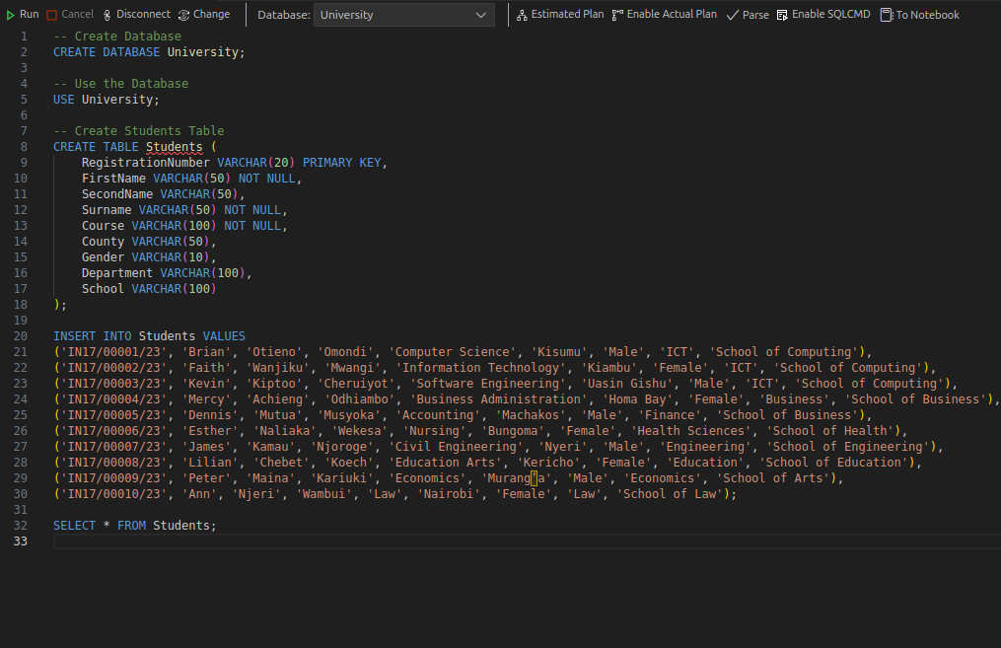
Fig 1. Database schema in Azure Data Studio
The image below shows the populated Students table with the initial ten records:
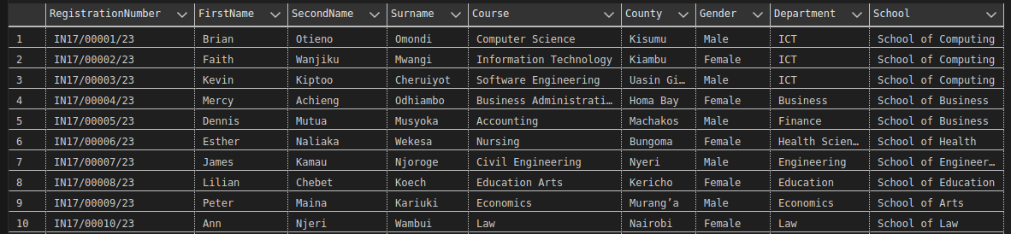
Fig 2. Students table with initial records

Step 2: UI Design Phase
This was an interactive phase where the user interface was built incrementally — one element at a time — until the complete interface was assembled. The process is illustrated below:
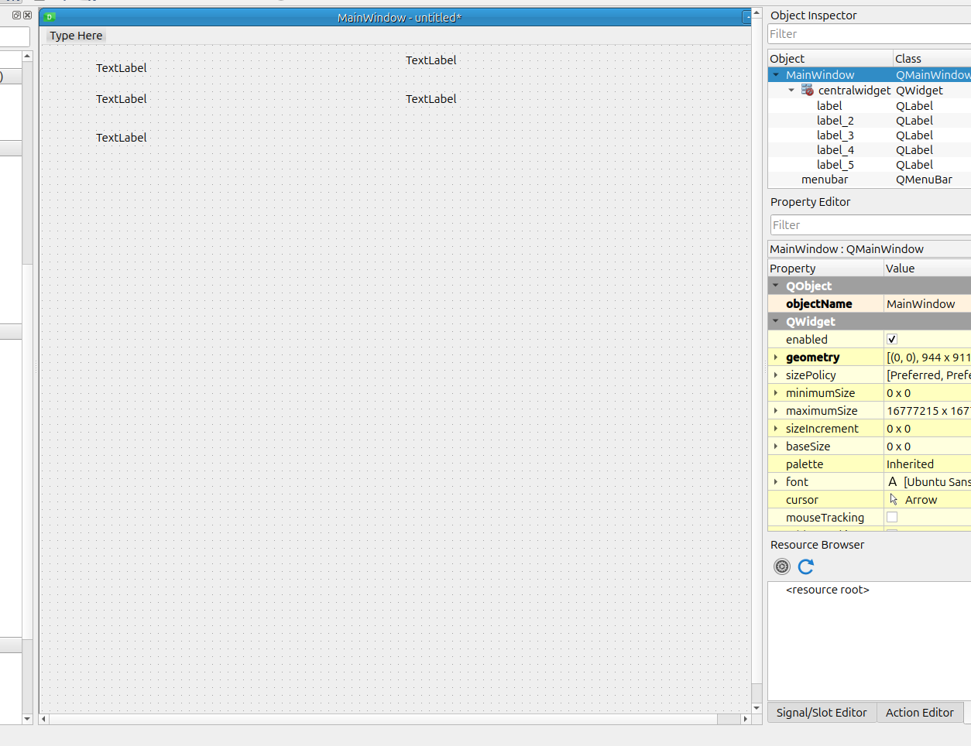
Fig 3. Adding text labels for field sections (Registration Number, First Name, etc.)
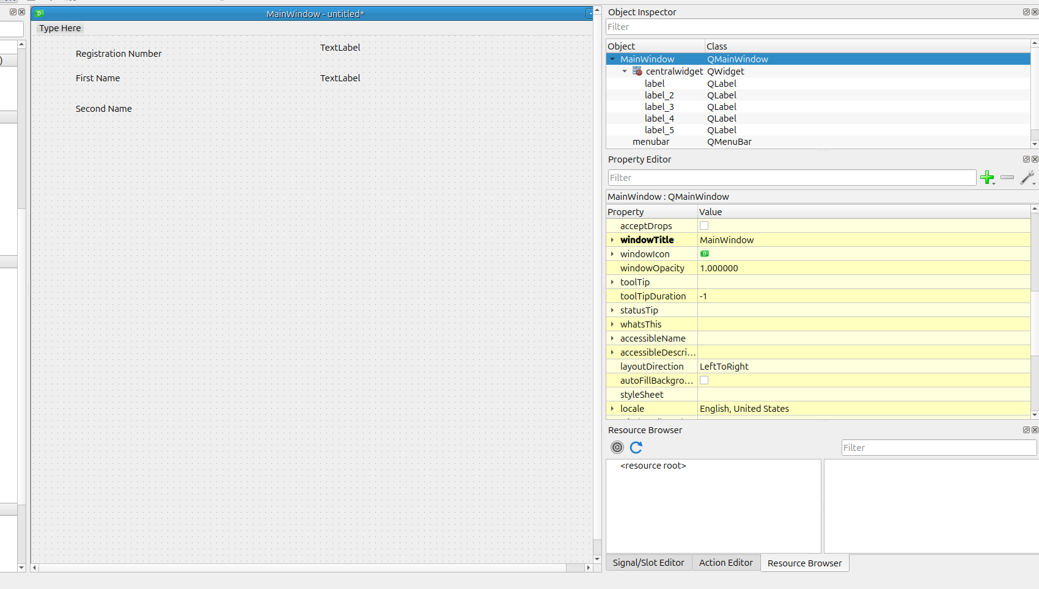
Fig 4. Assigning naming conventions to labels for easier identification
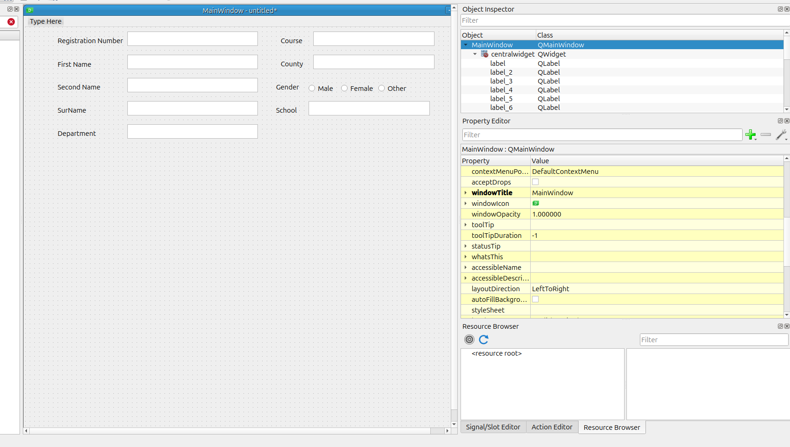
Fig 5. Adding line-edit inputs as data-holding fields linked to the University database
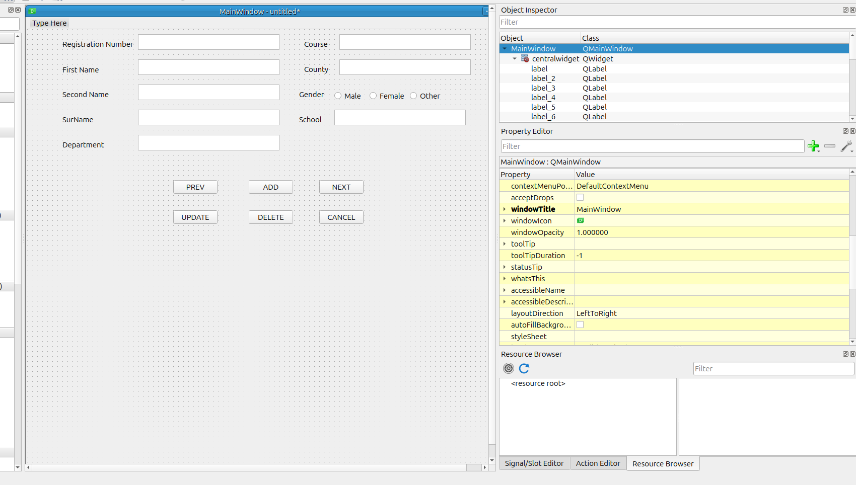
Fig 6. Adding action buttons — each will be mapped to Python functions
The final UI layout, including the Reset Database button and Search tab:
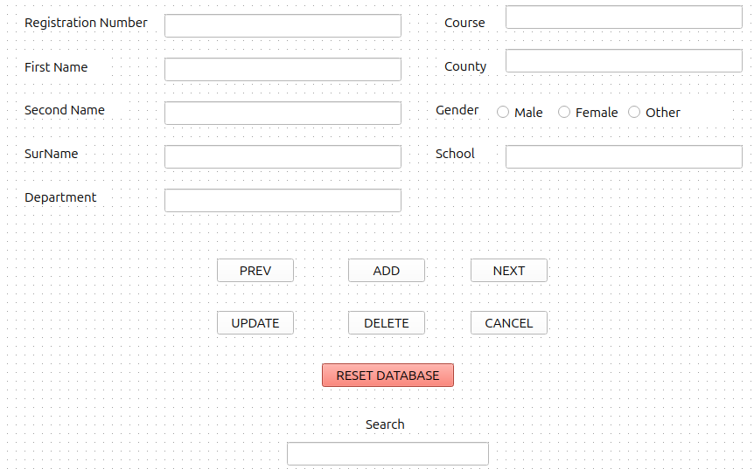
Fig 7. Final UI design with all components

Step 3: File Conversion (.UI to .PY)
This stage involved converting the .ui file to a .py file. The resulting Python script can display the UI when executed as a Jupyter Lab notebook.
The file was saved as student_information.ui and converted using the Pyuic5 package via the following terminal command:

pyuic5 student_information.ui -o student_information.py

This produces a .py script representing the UI in code form. This script is subsequently used to bind functions to buttons and labels in the following steps.

Step 4: Database Connection and Authentication
The database connection is established using pypyodbc. Install the package using:

pip install pypyodbc

The connection configuration script is as follows:

# ---------------------- DATABASE CONFIG ----------------------
DRIVER_NAME = "ODBC Driver 18 for SQL Server"
SERVER_NAME = "localhost"
DATABASE_NAME = "University"
USERNAME = "SA"
PASSWORD = "<your_password>"

connection_string = f"""
DRIVER={{{DRIVER_NAME}}};
SERVER={SERVER_NAME};
DATABASE={DATABASE_NAME};
UID={USERNAME};
PWD={PASSWORD};
TrustServerCertificate=yes;
"""

def connect_db():
return odbc.connect(connection_string)

Password authentication was mandatory as the system runs a protected database on Linux OS, using ODBC Driver 18 for SQL Server. The connection string includes the database name, username, and authentication credentials.
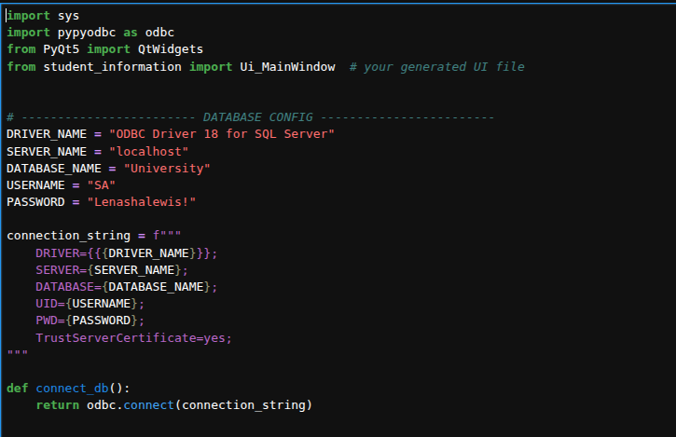
Fig 8. Database connection configuration in Jupyter Lab

Step 5: Main Python File
This is the core of the application — it includes button scripting, function definitions, and imports the previously generated .py UI file. It also implements the Reset Database feature and handles testing and debugging.
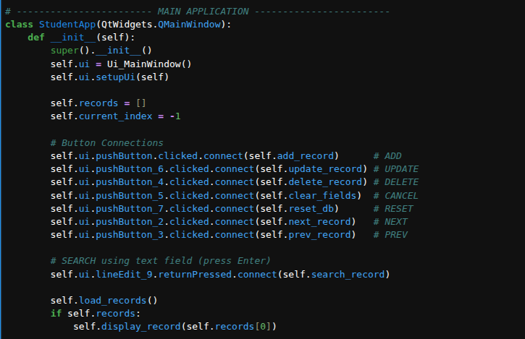
Fig 9. Class definition inheriting from QMainWindow with constructor and button connections
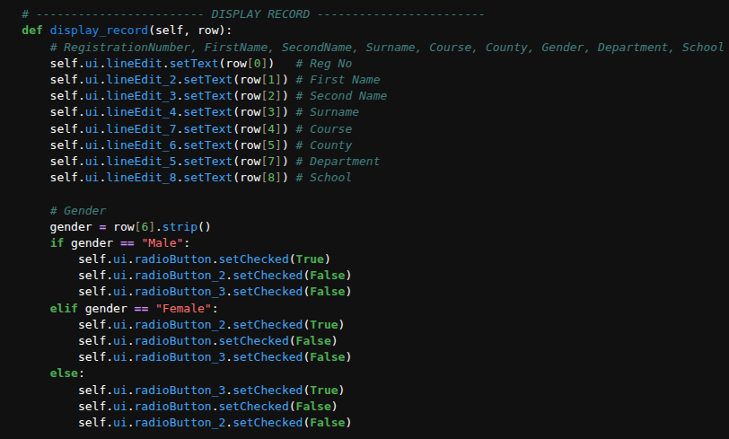
Fig 10. load_records() and display_record() function implementations

Function Reference

display_record(row)
Populates the GUI fields with data from a single database record.
Parameters:
- row (list): Contains values in order [RegistrationNumber, FirstName, SecondName, Surname, Course, County, Gender, Department, School]
Behavior:
- Text Fields — maps each row element to its corresponding QLineEdit widget
- row[0] → Registration Number | row[1] → First Name | row[2] → Second Name
- row[3] → Surname | row[4] → Course | row[5] → County | row[7] → Department | row[8] → School
- Gender Selection — reads row[6] and sets the appropriate radio button (Male / Female / Other)
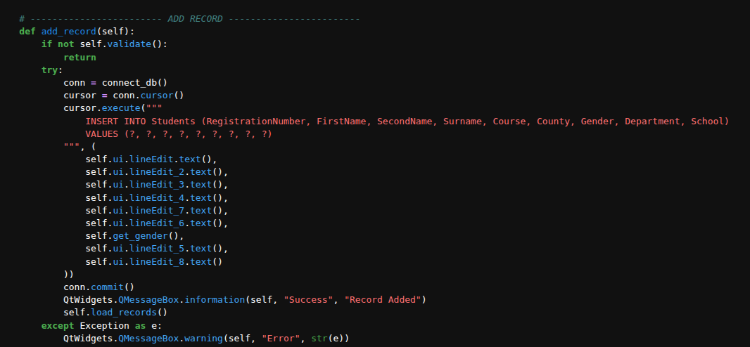
Fig 11. display_record() implementation

add_record()
Purpose: Adds a new student record to the database.
- Validates input before proceeding
- Executes an SQL INSERT INTO Students statement using values from GUI fields
- Commits changes and reloads records
- Displays success or error messages via QMessageBox
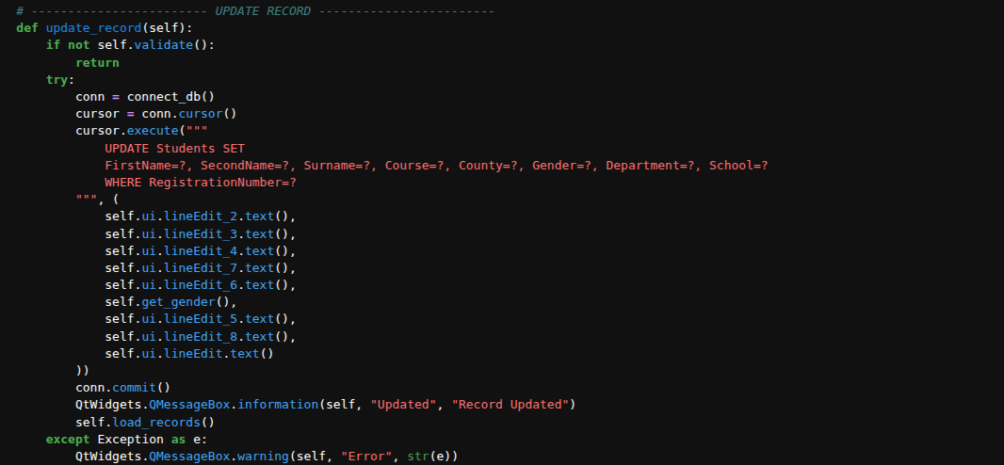
Fig 12. add_record() implementation

update_record()
Purpose: Updates an existing student record in the database.
- Validates input before proceeding
- Executes an SQL UPDATE Students SET ... WHERE RegistrationNumber=?
- Commits changes and reloads records
- Displays success or error messages
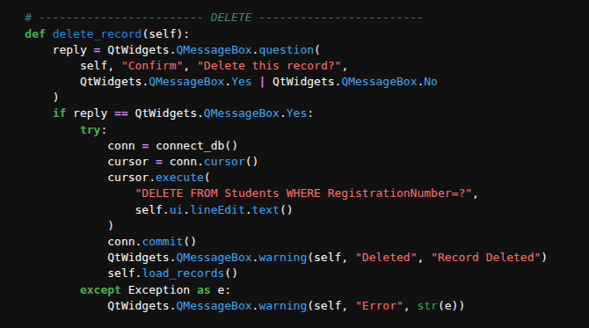
Fig 13. update_record() implementation

delete_record()
Purpose: Deletes a student record based on the registration number.
- Prompts the user for confirmation
- Executes an SQL DELETE FROM Students WHERE RegistrationNumber=?
- Commits changes and reloads records
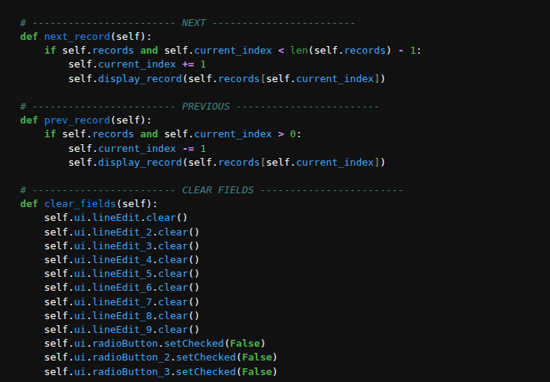
Fig 14. delete_record() implementation

next_record() / prev_record()
Purpose: Navigates through the list of loaded records.
- next_record() — moves forward if another record exists
- prev_record() — moves backward if a previous record exists
- Both call display_record() to update the GUI with the current record

clear_fields()
Purpose: Resets all input fields and radio buttons in the GUI.
- Clears text from all QLineEdit widgets
- Unchecks all gender radio buttons
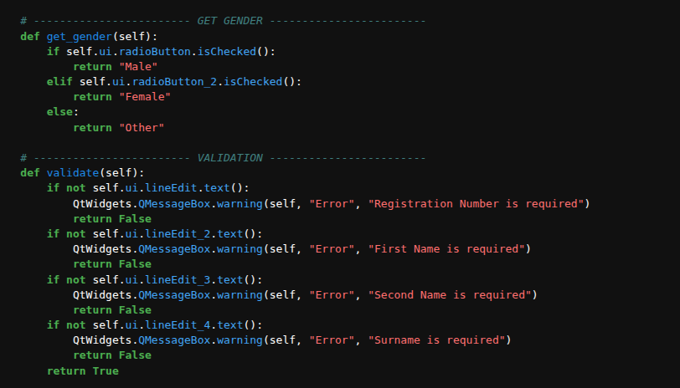
Fig 15. clear_fields() and navigation functions

get_gender()
Purpose: Determines the selected gender from the radio buttons.
- Returns "Male" if radioButton is checked
- Returns "Female" if radioButton_2 is checked
- Returns "Other" if neither is selected

validate()
Purpose: Ensures required fields are filled before database operations.
- Checks that Registration Number, First Name, Second Name, and Surname are not empty
- Displays a warning message if any required field is missing
- Returns True if all validations pass, otherwise False

reset_db()
Purpose: Clears all records from the Students table.
- Prompts the user for confirmation before proceeding
- Executes SQL DELETE FROM Students (removes all rows)
- Commits changes and reloads records
- Displays confirmation or error messages
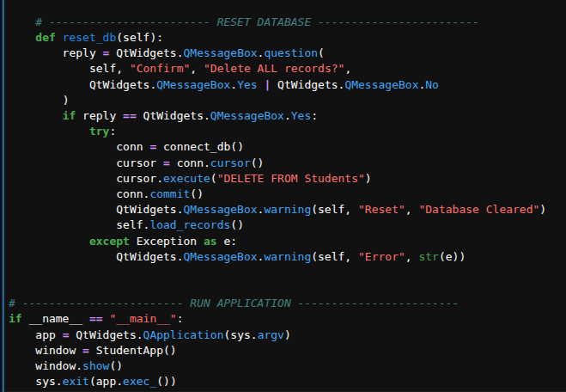
Fig 16. reset_db() implementation

search_record()
Purpose: Finds and displays a student record based on user input.
- Retrieves the search value from lineEdit_9
- Matches on RegistrationNumber OR (FirstName + ' ' + SecondName)
- If found: calls display_record(row) and shows a success message
- If not found: displays a warning message
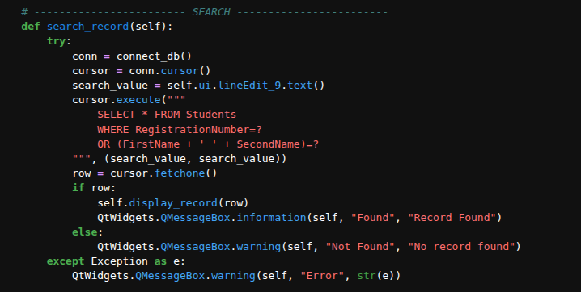
Fig 17. search_record() implementation

Final Full Python Script

import sys
import pypyodbc as odbc
from PyQt5 import QtWidgets
from student_information import Ui_MainWindow

# ---------------------- DATABASE CONFIG ----------------------
DRIVER_NAME = "ODBC Driver 18 for SQL Server"
SERVER_NAME = "localhost"
DATABASE_NAME = "University"
USERNAME = "SA"
PASSWORD = "<your_password>"

connection_string = f"""
DRIVER={{{DRIVER_NAME}}};
SERVER={SERVER_NAME};
DATABASE={DATABASE_NAME};
UID={USERNAME};
PWD={PASSWORD};
TrustServerCertificate=yes;
"""

def connect_db():
return odbc.connect(connection_string)

# ---------------------- MAIN APPLICATION ----------------------
class StudentApp(QtWidgets.QMainWindow):
def __init__(self):
super().__init__()
self.ui = Ui_MainWindow()
self.ui.setupUi(self)
self.records = []
self.current_index = -1

# Button Connections
self.ui.pushButton.clicked.connect(self.add_record) # ADD
self.ui.pushButton_6.clicked.connect(self.update_record) # UPDATE
self.ui.pushButton_4.clicked.connect(self.delete_record) # DELETE
self.ui.pushButton_5.clicked.connect(self.clear_fields) # CANCEL
self.ui.pushButton_7.clicked.connect(self.reset_db) # RESET
self.ui.pushButton_2.clicked.connect(self.next_record) # NEXT
self.ui.pushButton_3.clicked.connect(self.prev_record) # PREV
self.ui.lineEdit_9.returnPressed.connect(self.search_record)

self.load_records()
if self.records:
self.display_record(self.records[0])

# ---------------------- LOAD RECORDS ----------------------
def load_records(self):
conn = connect_db()
cursor = conn.cursor()
cursor.execute("SELECT * FROM Students")
self.records = cursor.fetchall()
self.current_index = 0 if self.records else -1

# ---------------------- DISPLAY RECORD ----------------------
def display_record(self, row):
self.ui.lineEdit.setText(row[0]) # Reg No
self.ui.lineEdit_2.setText(row[1]) # First Name
self.ui.lineEdit_3.setText(row[2]) # Second Name
self.ui.lineEdit_4.setText(row[3]) # Surname
self.ui.lineEdit_7.setText(row[4]) # Course
self.ui.lineEdit_6.setText(row[5]) # County
self.ui.lineEdit_5.setText(row[7]) # Department
self.ui.lineEdit_8.setText(row[8]) # School
gender = row[6].strip()
if gender == "Male":
self.ui.radioButton.setChecked(True)
self.ui.radioButton_2.setChecked(False)
self.ui.radioButton_3.setChecked(False)
elif gender == "Female":
self.ui.radioButton_2.setChecked(True)
self.ui.radioButton.setChecked(False)
self.ui.radioButton_3.setChecked(False)
else:
self.ui.radioButton_3.setChecked(True)
self.ui.radioButton.setChecked(False)
self.ui.radioButton_2.setChecked(False)

# ---------------------- GET GENDER ----------------------
def get_gender(self):
if self.ui.radioButton.isChecked(): return "Male"
elif self.ui.radioButton_2.isChecked(): return "Female"
else: return "Other"

# ---------------------- VALIDATION ----------------------
def validate(self):
if not self.ui.lineEdit.text():
QtWidgets.QMessageBox.warning(self, "Error", "Registration Number is required")
return False
if not self.ui.lineEdit_2.text():
QtWidgets.QMessageBox.warning(self, "Error", "First Name is required")
return False
if not self.ui.lineEdit_3.text():
QtWidgets.QMessageBox.warning(self, "Error", "Second Name is required")
return False
if not self.ui.lineEdit_4.text():
QtWidgets.QMessageBox.warning(self, "Error", "Surname is required")
return False
return True

# ---------------------- ADD RECORD ----------------------
def add_record(self):
if not self.validate(): return
try:
conn = connect_db(); cursor = conn.cursor()
cursor.execute("""
INSERT INTO Students (RegistrationNumber, FirstName, SecondName,
Surname, Course, County, Gender, Department, School)
VALUES (?, ?, ?, ?, ?, ?, ?, ?, ?)""",
(self.ui.lineEdit.text(), self.ui.lineEdit_2.text(),
self.ui.lineEdit_3.text(), self.ui.lineEdit_4.text(),
self.ui.lineEdit_7.text(), self.ui.lineEdit_6.text(),
self.get_gender(), self.ui.lineEdit_5.text(), self.ui.lineEdit_8.text()))
conn.commit()
QtWidgets.QMessageBox.information(self, "Success", "Record Added")
self.load_records()
except Exception as e:
QtWidgets.QMessageBox.warning(self, "Error", str(e))

# ---------------------- UPDATE RECORD ----------------------
def update_record(self):
if not self.validate(): return
try:
conn = connect_db(); cursor = conn.cursor()
cursor.execute("""
UPDATE Students SET
FirstName=?, SecondName=?, Surname=?, Course=?,
County=?, Gender=?, Department=?, School=?
WHERE RegistrationNumber=?""",
(self.ui.lineEdit_2.text(), self.ui.lineEdit_3.text(),
self.ui.lineEdit_4.text(), self.ui.lineEdit_7.text(),
self.ui.lineEdit_6.text(), self.get_gender(),
self.ui.lineEdit_5.text(), self.ui.lineEdit_8.text(),
self.ui.lineEdit.text()))
conn.commit()
QtWidgets.QMessageBox.information(self, "Updated", "Record Updated")
self.load_records()
except Exception as e:
QtWidgets.QMessageBox.warning(self, "Error", str(e))

# ---------------------- DELETE ----------------------
def delete_record(self):
reply = QtWidgets.QMessageBox.question(self, "Confirm", "Delete this record?",
QtWidgets.QMessageBox.Yes | QtWidgets.QMessageBox.No)
if reply == QtWidgets.QMessageBox.Yes:
try:
conn = connect_db(); cursor = conn.cursor()
cursor.execute("DELETE FROM Students WHERE RegistrationNumber=?",
self.ui.lineEdit.text())
conn.commit()
QtWidgets.QMessageBox.warning(self, "Deleted", "Record Deleted")
self.load_records()
except Exception as e:
QtWidgets.QMessageBox.warning(self, "Error", str(e))

# ---------------------- SEARCH ----------------------
def search_record(self):
try:
conn = connect_db(); cursor = conn.cursor()
search_value = self.ui.lineEdit_9.text()
cursor.execute("""
SELECT * FROM Students
WHERE RegistrationNumber=?
OR (FirstName + ' ' + SecondName)=?""",
(search_value, search_value))
row = cursor.fetchone()
if row:
self.display_record(row)
QtWidgets.QMessageBox.information(self, "Found", "Record Found")
else:
QtWidgets.QMessageBox.warning(self, "Not Found", "No record found")
except Exception as e:
QtWidgets.QMessageBox.warning(self, "Error", str(e))

# ---------------------- NAVIGATION ----------------------
def next_record(self):
if self.records and self.current_index < len(self.records) - 1:
self.current_index += 1
self.display_record(self.records[self.current_index])

def prev_record(self):
if self.records and self.current_index > 0:
self.current_index -= 1
self.display_record(self.records[self.current_index])

# ---------------------- CLEAR FIELDS ----------------------
def clear_fields(self):
for le in [self.ui.lineEdit, self.ui.lineEdit_2, self.ui.lineEdit_3,
self.ui.lineEdit_4, self.ui.lineEdit_5, self.ui.lineEdit_6,
self.ui.lineEdit_7, self.ui.lineEdit_8, self.ui.lineEdit_9]:
le.clear()
self.ui.radioButton.setChecked(False)
self.ui.radioButton_2.setChecked(False)
self.ui.radioButton_3.setChecked(False)

# ---------------------- RESET DATABASE ----------------------
def reset_db(self):
reply = QtWidgets.QMessageBox.question(self, "Confirm", "Delete ALL records?",
QtWidgets.QMessageBox.Yes | QtWidgets.QMessageBox.No)
if reply == QtWidgets.QMessageBox.Yes:
try:
conn = connect_db(); cursor = conn.cursor()
cursor.execute("DELETE FROM Students")
conn.commit()
QtWidgets.QMessageBox.warning(self, "Reset", "Database Cleared")
self.load_records()
except Exception as e:
QtWidgets.QMessageBox.warning(self, "Error", str(e))

# ---------------------- RUN APPLICATION ----------------------
if __name__ == "__main__":
app = QtWidgets.QApplication(sys.argv)
window = StudentApp()
window.show()
sys.exit(app.exec_())

Step 6: Final Testing and Error Debugging
The following screenshots demonstrate the fully working application after running the complete Python script. The interface automatically displays the first record from the database on launch.
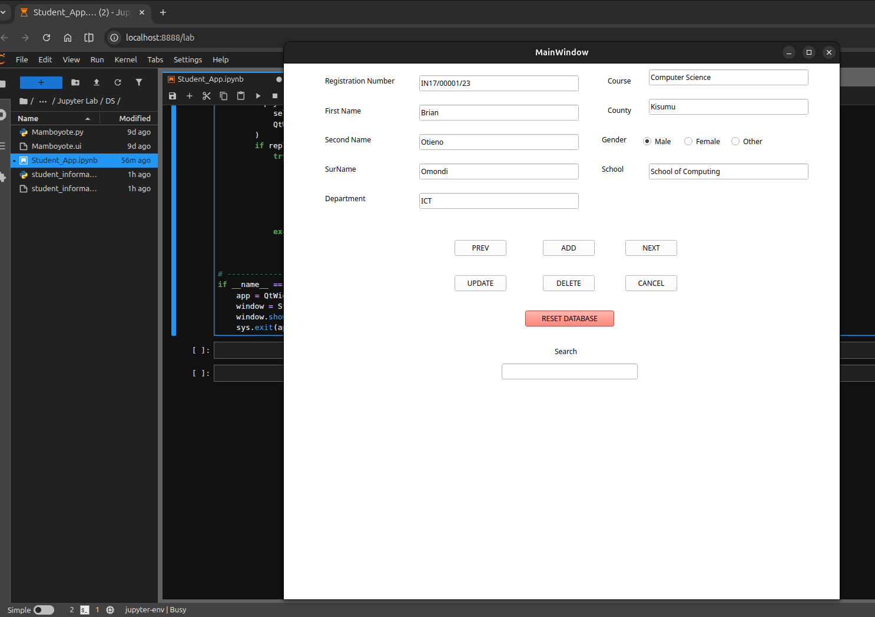
Fig 18. Application launch — first student record displayed automatically

Test 1: Next Record
Navigates to and displays the next student's details.
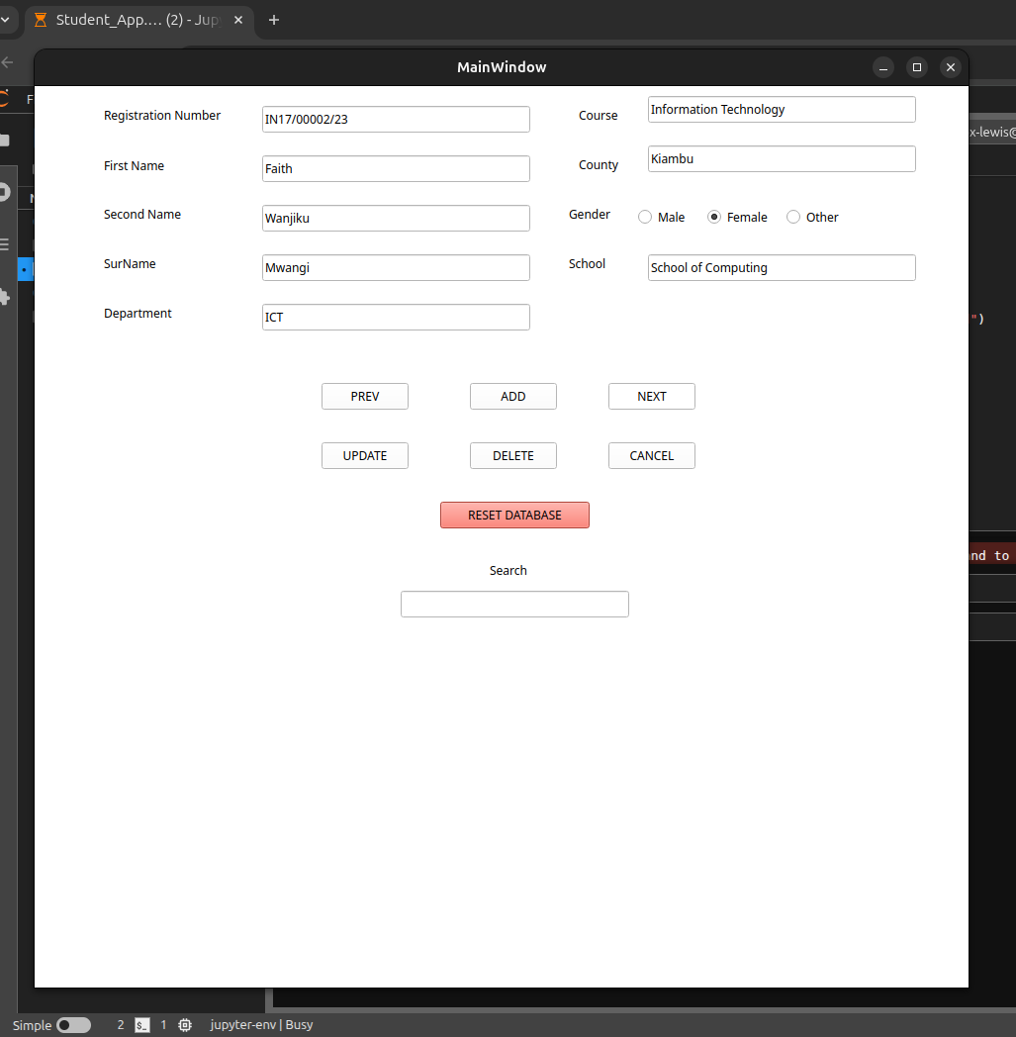
Fig 19. Next Record — displaying the second student entry

Test 2: Update Record
Demonstrates adding / updating a student record in the table.
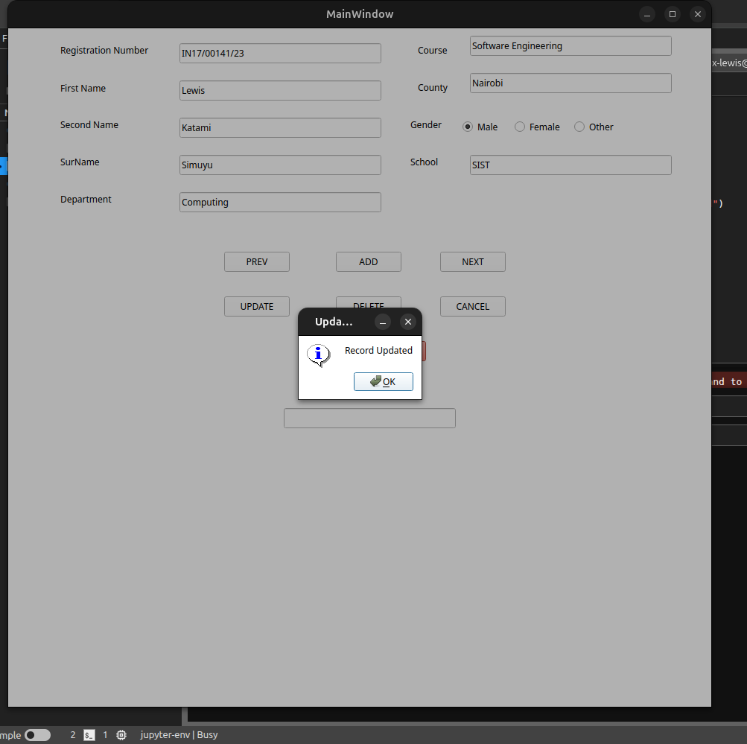
Fig 20. Update Record — editing an existing entry

Test 3: Delete Record
Demonstrates deleting a student record from the database.
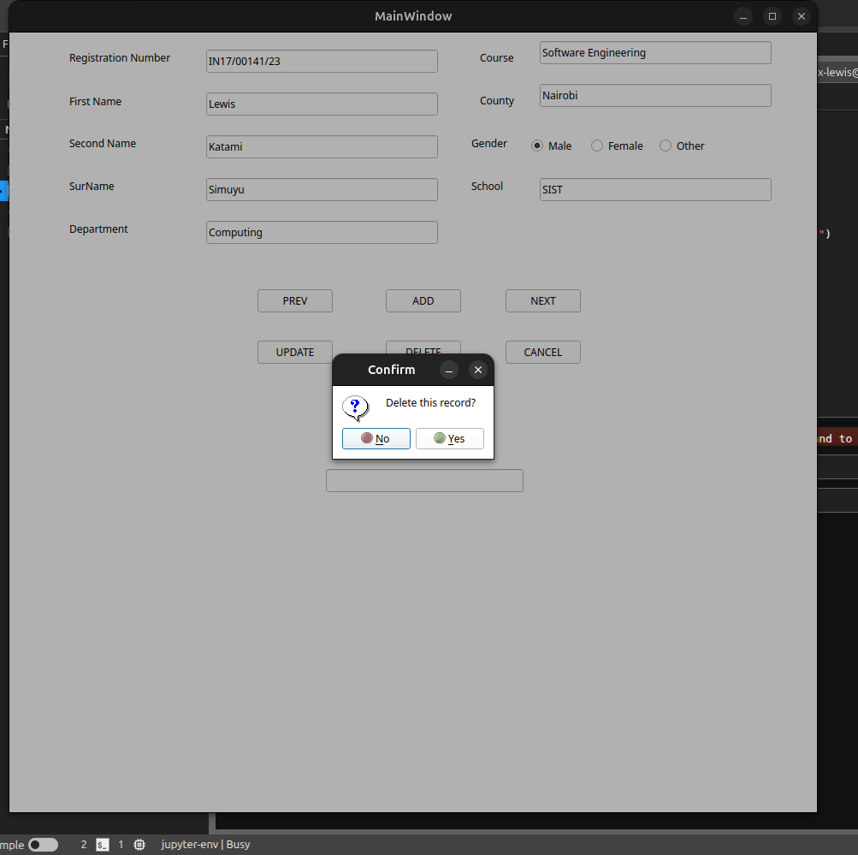
Fig 21. Delete Record — confirmation dialog and record removal

— End of Assignment —

